ConLAS
Laser Source

Software instructions
(V1.1)

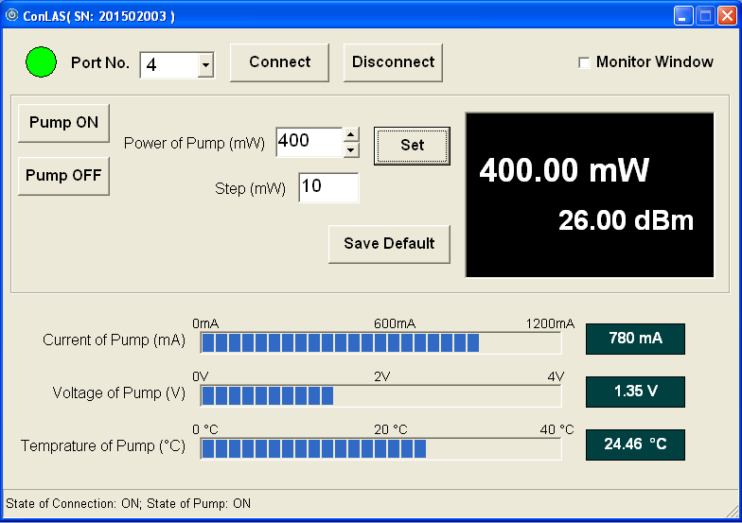

CONTENTS

1 Outline………………………………….………………………………………………3
2 Software installation…………………………………….……………………….4
2.1 Software installation conditions…..………………………………………4
2.2 Installation Steps………………………………………………………….........4-7
3 Software application……………………………………………………….….…8
3.1 The port number confirmation………………………………………….…8-10
3.2 Start-up Screen……….……………………………………………………..……10
3.3 Moudle connection…………………………..…………….…..………………11
3.4 Source on………………………………………………..……………………..……12
3.5 Power setting…………..…………………………………....……………………12
3.6 Current value saving……………………………………………..…….............13
3.7 Source off…………………………………………………………......................13
3.8 Window monitoring……………………………………………….................14

1.Outline
  - This part includes the installations and instructions of the software“ConLAS”；
  - ConLAS is designed for applying to the software for VENUS series laser source including bentchtops and modules，and having graphical user interface，is operated under the Microsoft Windows systems；
  - As ConLAS is being used,make sure the serial port cable which is controlling the single amplifier or a serial port hub or USB to a serial port hub which is controlling multiple amplifiers are connected between the computers and the modules. We recommend Z-TEK USB and DB9 tielines and please setup the tielines driver correctly; as to the modules have been built-in USB interfaces,you can connet USB-A to USB-B cables between computer and module directly；
  - As to the modules with built-in USB interfaces，you need to install USB drivers under the place of “\USB serial port drivers”；
  - If you have any problems,please don’t hesitate to contact us.

2. Software installation
2.1 Software installation conditions：MicroSoft Windows XP（SP2 aboved）or Win7、Win8；
2.2 Software installation steps：
steps | instructions
1 | Insert a disk，or perating “setup.exe” under the content of setup.
2 | Showing the interface as follows，then click the button“next step”  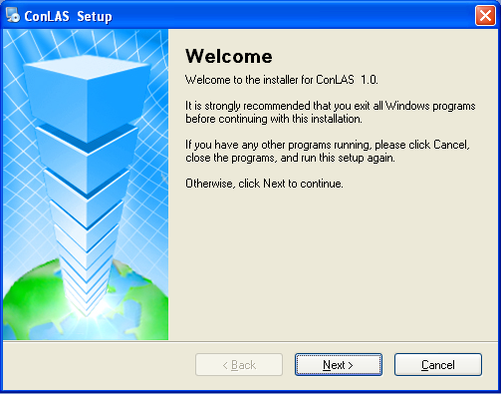
3 | Showing the information of user and product，then click the button “next step”  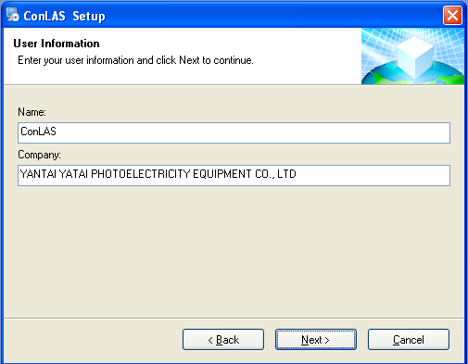
4 | Choosing the installation paths, the default path is：C:\Program Files\Laser Source\，or user-defined installation paths.  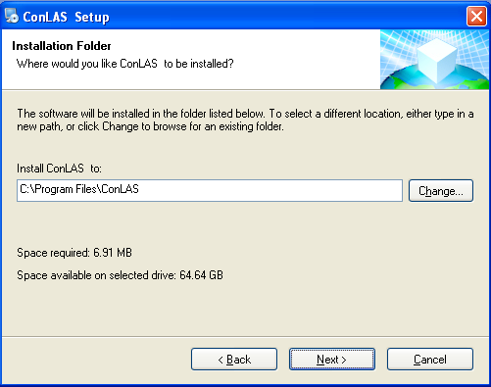
5 | Creating the shortcut  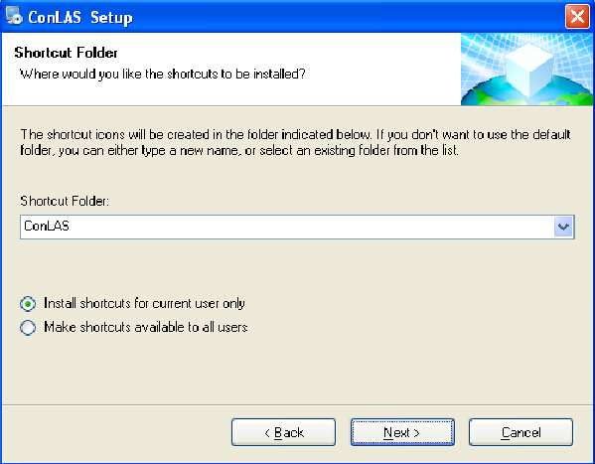

6 | Being ready to install  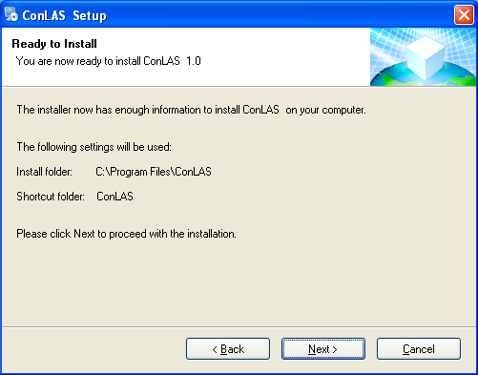
7 | Starting to install  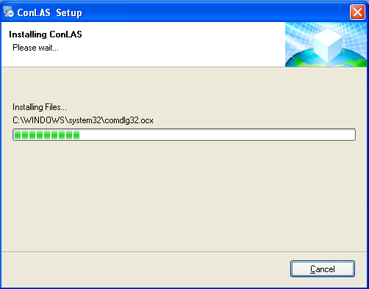
steps | instructions
1 | Insert a disk，or perating “setup.exe” under the content of setup.
2 | Showing the interface as follows，then click the button“next step”
3 | Showing the information of user and product，then click the button “next step”
4 | Choosing the installation paths, the default path is：C:\Program Files\Laser Source\，or user-defined installation paths.
5 | Creating the shortcut
6 | Being ready to install
7 | Starting to install
8 | After the installation is successful, you can run this software from the start menu as well as creating a shortcut on the desktop.  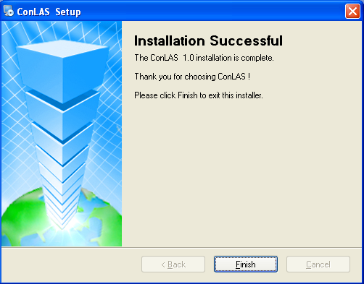

3．Software application
3.1．The port number confirmation
After installing the USB serial port connections correctly, the system will assign a port number which would be used to connect modules and computers. Please check as follow：
3.1.1．“ my computer”—— “attribute”—— “system attribute”：
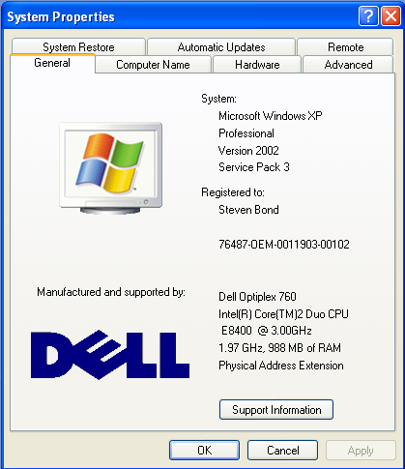

3.1.2.Click “Hardware”：
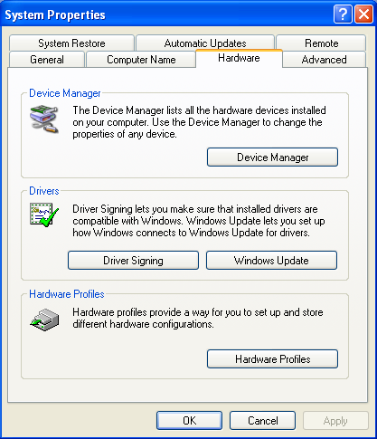

3.1.3. Click “Device Manager”：
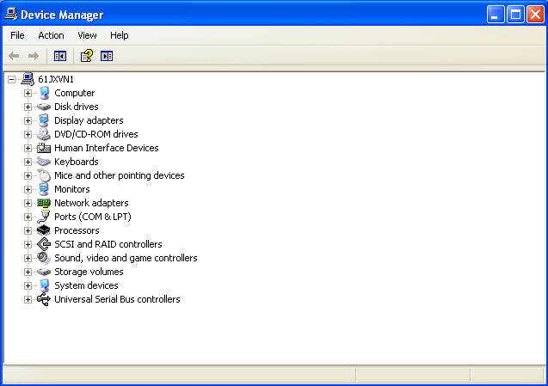

3.1.4.Click“Port(COM and LPT)”to check the port number：
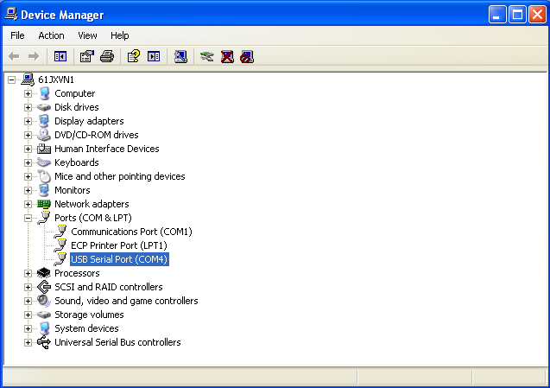
As shown in the image above,the port number is 4. When you use ConLAS for the first time, you need to input number 4 in the select box and the port number will be remembered. when you use ConLAS again in the same computer, the port number is the default.
3.2. Start-up Screen
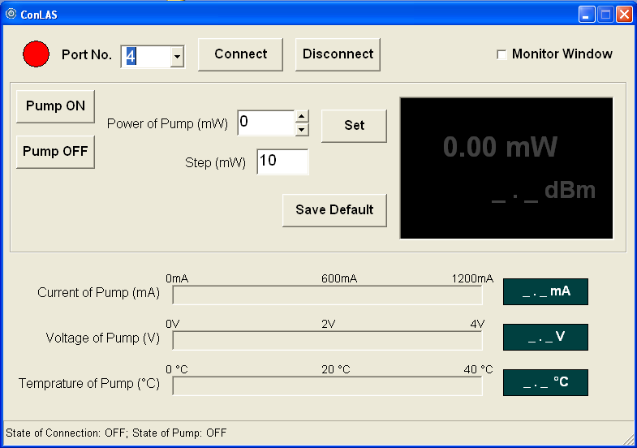
The port is not opened, indicator light is red, the status line shows “connection Status：OFF；source state：OFF”.
3.3．Moudle connection
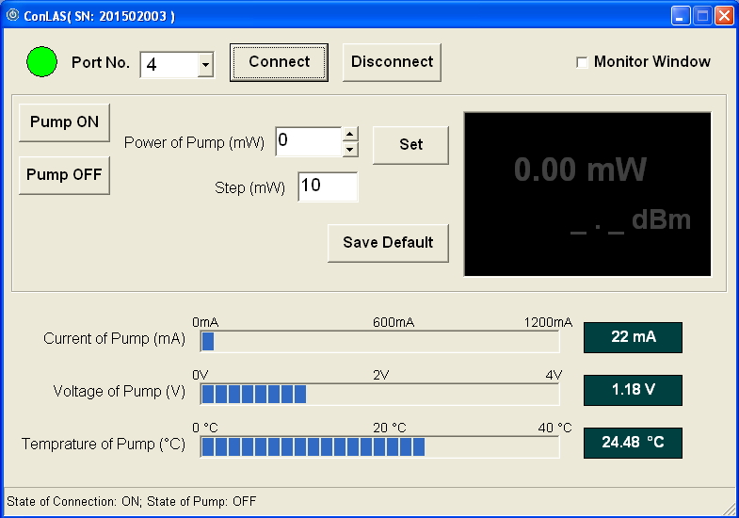
Please click “Connect”to make sure the connection is successful between computer and module. If the connection is successful, the indicator light is green, the titlebar shows serial numbers ,the connection status shows ON as well as the Pump Current, Pump Voltage and Pump Temperature will be shown.
If there is no electricity or setting wrong port number or improper connection, the software”ConLAS” will give you the tip as follow: please check out whether something is wrong with the electricity or port number or connecting line.
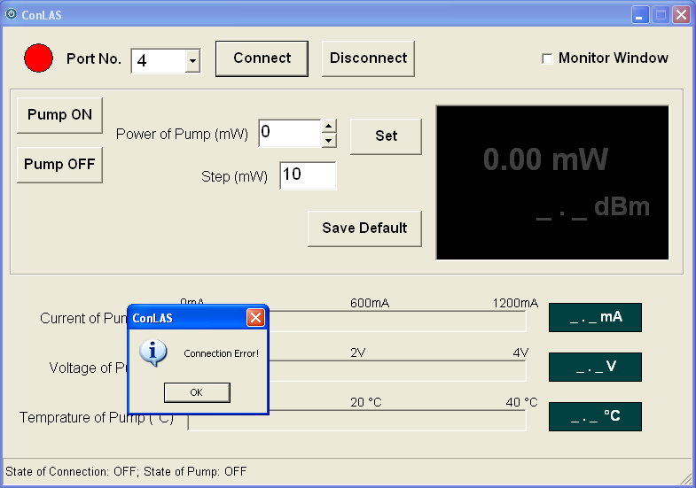
3.4. Source on
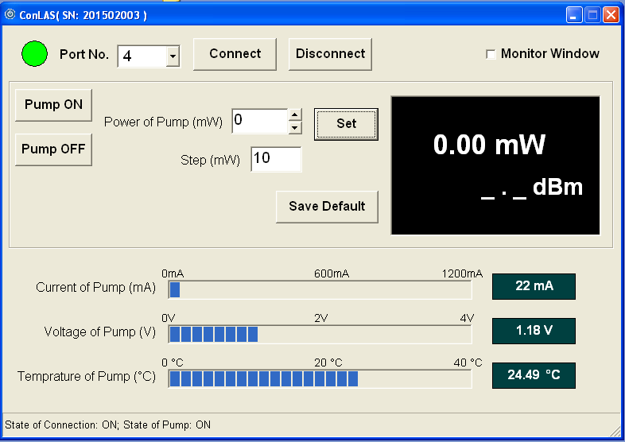
When it is connected successfully between the software”ConLAS” and the module,please click “Pump ON” to make sure the module is working. Then,the area which shows the power is bright, regarding to the connection status and the source status, both of them show “ON”.
If you have already saved the power value before,the output power value is the default.
3.5. Power setting
You can set the power pump value in the input box after the laser being turned on, you can also change the single step adjustment precision through inputting the value in the box. When you finish setting up all the parameters, the power value and all the parameters of Pump will be shown in the interface of ConLAS.
3.6.Current value saving
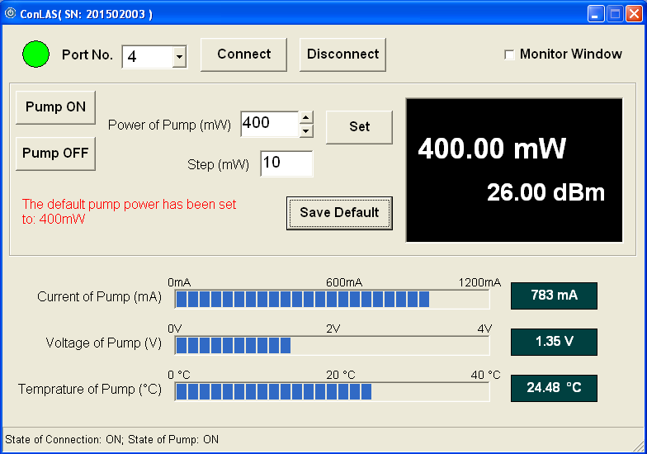
Click the button”Save Default”,the current output power value will be saved, when you turn on the laser again, the current output power value is the default.
3.7. Source off
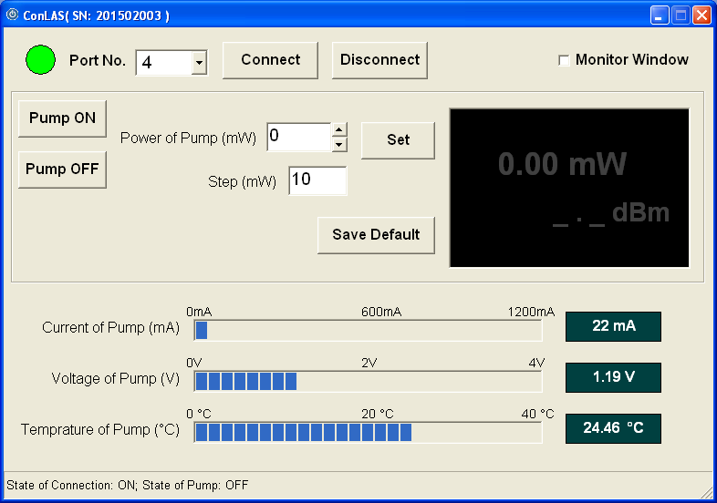
Click the button”Pump OFF”, the output power value is 0, as well as the area which shows the power is grey and the souce status shows”OFF”.
3.8. Window monitoring

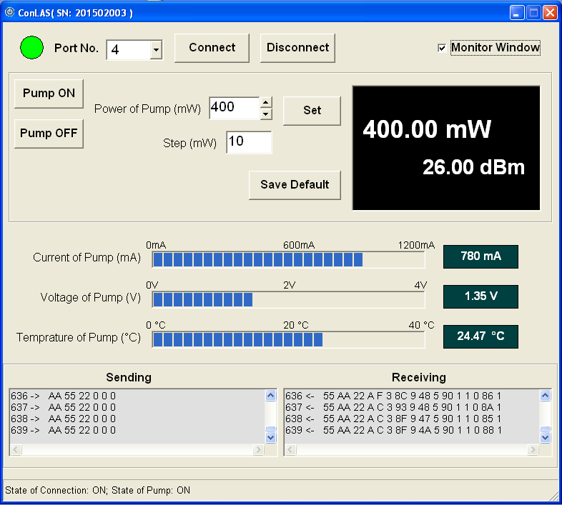
As to the users who develop the software by themselves, you can open”window monitoring” at the bottom of the interface, which is convenient to develop and debug by showing the hexadecimal numbers.

